Solution for Equation 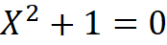

Shaimaa said soltan¹

¹ Computer Engineer, Toronto, Canada

Correspondence: Shaimaa Soltan, 3050 Constitution Blvd, Mississauga, ON., L4Y 3X1, Canada. Tel: 1-647-801-6063 E-mail: shaimaasultan@hotmail.com

---------------------------------------------------------------------------------------------------------------------------------
Suggested Reviewers (Optional)

Please suggest 3-5 reviewers for this article. We may select reviewers from the list below in case we have no appropriate reviewers for this topic.

Name: | E-mail:

Affiliation:

Name: | E-mail:

Affiliation:

Name: | E-mail:

Affiliation:

Name: | E-mail:

Affiliation:

Name: | E-mail:

Affiliation:

Solution for Equation

Abstract
In this paper we used an equality relation from complex plane to find the solution for the know quadratic equation
Keywords: zeta function, Riemann hypothesis, complex plane, none-trivial zeros, critical strip

1. Introduction

- For any Natural numebr [A]
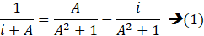
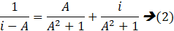
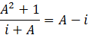
- Rearrange equation (1) and (2)
We will use to get the Zeros and solution for based on the Equality equation (4).

- Another form for the equality relation
For positive Zeros
For negative Zeros

Table 1. Positive Zeros for the equality relation
A
1 | 2 | 2 | 2
2 | 5 | 5 | 5
3 | 10 | 10 | 10
4 | 17 | 17 | 17
5 | 26 | 26 | 26
6 | 37 | 37 | 37
7 | 50 | 50 | 50
8 | 65 | 65 | 65
9 | 82 | 82 | 82
10 | 101 | 101 | 101
11 | 122 | 122 | 122
12 | 145 | 145 | 145
13 | 170 | 170 | 170

Table 2. Negative Zeros for the equality relation
A | (-
1 | 0 | 2 | 0
2 | -3 | 5 | -3
3 | -8 | 10 | -8
4 | -15 | 17 | -15
5 | -24 | 26 | -24
6 | -35 | 37 | -35
7 | -48 | 50 | -48
8 | -63 | 65 | -63
9 | -80 | 82 | -80
10 | -99 | 101 | -99
11 | -120 | 122 | -120
12 | -143 | 145 | -143
13 | -168 | 170 | -168

- First visualize these two functions in a complex plane
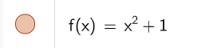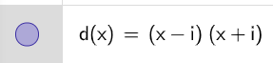
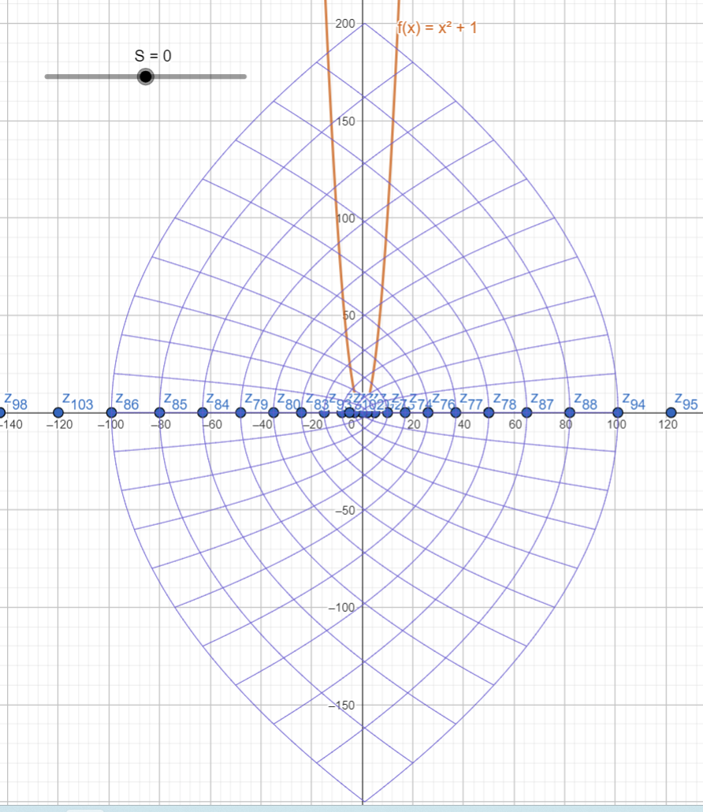
Figure 1. Shows the visualization for both function and for function

- Positive Zeros for
all points that are zeros for are the points that equation contour lines intersects with x axis in complex plane
For examples for positive Zeros Table 1. have examples for some zeros for some values of A for positive Zeros.
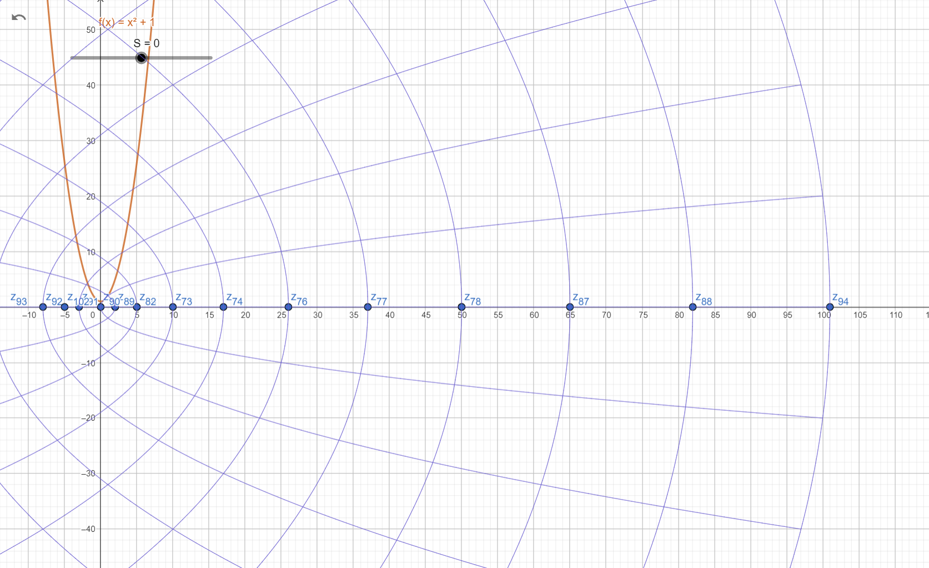
Figure 2. Positive Zeros for function at x axis in complex plane.

- Negative Zeros for
all points that are zeros for are the points that equation contour lines intersect with x axis in complex plane.
For examples for positive Zeros Table 2. have examples for some zeros for some values of A for Negative Zeros.
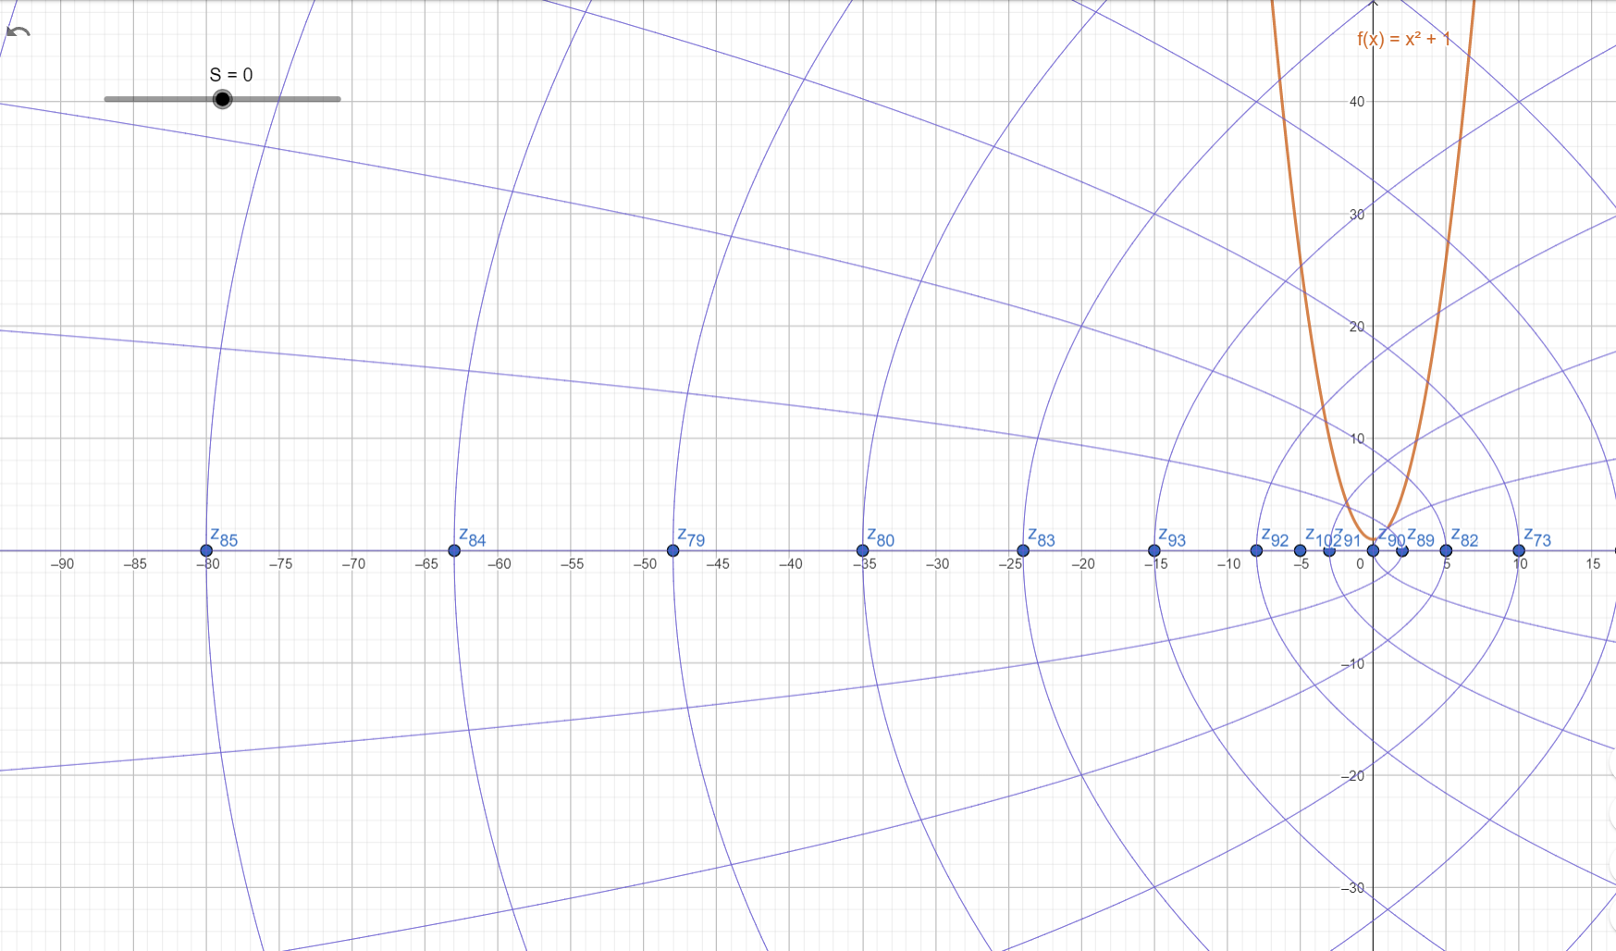
Figure 3. Negative Zeros for function at x axis in complex plane.

Conclusion
In this paper we used an equality relation from complex plane to find the solution for the know quadratic equation

By finding the Zeros for function we can find the Zeros for

References
"Series expansion - Encyclopedia of Mathematics". encyclopediaofmath.org. 7 February 2011. Retrieved 12 August 2021.
^ "Series and Expansions". Mathematics LibreTexts. 2013-11-07. Retrieved 2021-12-24.
^ Gil, Amparo; Segura, Javier; Temme, Nico M. (2007-01-01). Numerical Methods for Special Functions. SIAM. ISBN 978-0-89871-782-2.
^ Jump up to:a b "Taylor series - Encyclopedia of Mathematics". encyclopediaofmath.org. 27 December 2013. Retrieved 22 March 2022.

